B I R M I N G H A M S E T T L E M E N T P R E S E N T S

CELEBRATE ASTON
A COMMUNITY FUN DAY

F E A T U R I N G

SATURDAY 16TH SEPTEMBER
11AM
- 4PM
P E R F O R M A N C E S , F R E E F I T N E S S ,
S P O R T & A R T T A S T E R S , F O O D F R O M A R O U N D T H E W O R L D , A N E X H I B I T I O N F R O M L O C A L A R T I S T S , M E H N D I ,
F A C E P A I N T I N G , K I D S ' A C T I V I T I E S & M U C H M O R E !

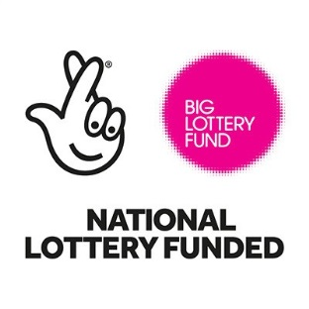
at Birmingham Settlement - Aston 359 - 361 Witton Road, B6 6NS

0121 250 0719
www.birminghamsettlement.org. uk
Reg. Charity No. 517303

PROGRAMME

PERFORMANCES
(with optional audience participation!) 11am: Britain's Got Talent's Hoop Guy - Stilt Walking
11.45am: Lily's Dance Company 12.30pm: Hoop Guy's Circus Skills & Hula Hooping
1.15pm: Bhangracise
2pm: Fun Family Fitness 2.45pm: Millie Langton (singer) 3pm: Broadway Dance Company

WORLD RESTAURANT
Food from around the world will be available throughout the day, so whether you fancy a quick snack or a light bite for lunch, be sure to check it out.

TASTERS & ACTIVITIES
11am & 12.30pm: Fun fitness session
11.45am, 1.15pm & 2pm: Variety of sports sessions including Tai Chi, Table Tennis and Badminton 1.15pm: Bhangracise

Throughout The Day: Face Painting & Mehndi Kids' craft activities Smoothie Bike
Art taster for all ages Local Artists' Exhibition
The emergency services (including Fire Engine!) "Museum in a Box" - collection of historical items Balloon Modelling
Community Engagement & Discussions

STALLS
We also have a range of information stalls from organisations in the local community where you can learn more about local services and opportunities available along with fun and games on offer throughout the day.

Reg. Charity No. 517303

