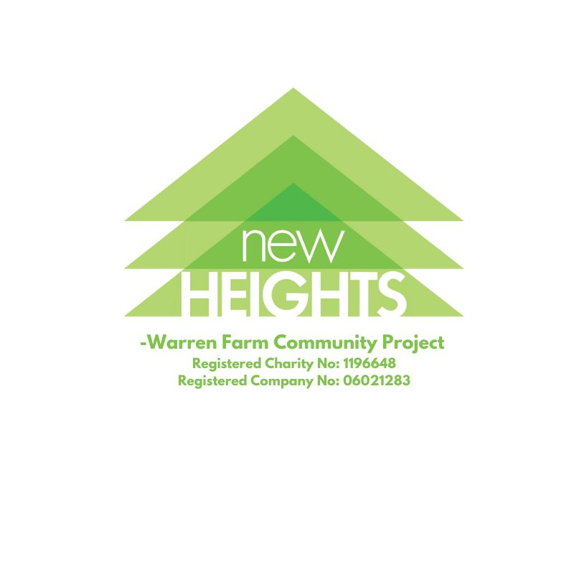
New Heights creates a safe, confidential and friendly space to help people by nurturing, empowering and giving the opportunity to flourish. We respond to community needs by delivering services and activities

ADULT SAFEGUARDING POLICY

New Heights Warren Farm Community Project will be referred to as New Heights or NHWFCP throughout this policy

Adult Safeguarding Policy

(This policy links to the NHWFCP Safeguarding and Child Protection Policy and Procedure; Adult Care - Statement of Residents Rights; Accident/Incidents Policy; Complaint’s Procedure, Whistleblowing Policy; Disciplinary Procedure; Adult Care - Decision Making Policy)

- Introduction ‘The Wellbeing Principle’

  - The 2014 Care Act requires all care providers and individual carers to observe the “wellbeing” principle. This puts an individual’s sense of wellbeing at the core of what we do and how we care for people. This means that we should constantly look for ways in which we can improve outcomes for people with care and support needs. This Safeguarding policy is a part of that strategy, as freedom from any kind of Abuse, is a right people have and key to a person’s wellbeing.

- Protection From Abuse – Principles:

  - New Heights is committed to providing services to Adults based on the overriding principles that their safety and wellbeing is paramount and that all staff and volunteers have a duty to safeguard this.

- People we care for and support will be treated with respect for their individuality, diversity and human rights.
- Each will be able to receive the care and support to which they are entitled without fear of any kind of abusive behaviour being directed towards them.
- Each person will, therefore, conduct himself or herself in such a way that they cause no deliberate or un-intentional offence to any other.
- Any abuse of power or privilege, whether perpetrated by staff, volunteers, visitors or other service users, will be addressed promptly and in accordance with the relevant internal and external policies and procedures.
- This policy is a guidance document for staff and volunteers to follow to ensure they know the possible types of abuse and what to do if they suspect a person’s wellbeing is threatened.

- Adults at Risk of Abuse

  - The Care Act 2014 defines an adult at risk as a person:
- Who is 18 years and over
- Who has needs for care and support (whether or not the local authority is meeting any of those needs)
- Is experiencing, or at risk of abuse or neglect
- Who as a result of those care and support needs is unable to protect themselves from either the risk of or the experience of abuse or neglect
- Care and support needs could be temporary or permanent.

  - This may include adults who:
- Are frail due to age, ill health, physical disability or cognitive impairment
- Have learning disabilities
- Have physical disabilities and or have a sensory impairment
- Have a mental health condition/disorder or dementia
- Have a long-term illness/condition
- Are misusing substances or alcohol
- Are unable to demonstrate the capacity to make a decision and in need of care and support

- Definition of Abuse

  - The term “abuse” can be subject to wide interpretation. Abuse may consist of a single act or repeated acts. It may be physical, verbal or psychological, it may be an act of neglect or a failure to act appropriately or it may occur when a vulnerable person is persuaded to enter into a financial or sexual transaction to which he or she has not consented, or cannot consent to due to lack of capacity. Abuse can occur in any relationship and may result in significant harm to, or exploitation of, the person subjected to it.

  - Incidents of abuse may be multiple, either to one person in a continuing relationship or service context, or to more than one person at a time. Some instances of abuse will constitute a criminal offence. It is unlawful to abuse a person. Criminal charges can be brought against the abuser under the Human Rights Act 1998, The Mental Capacity Act 2005, The Care Act 2014, The Modern Day Slavery Act 2015. External Safeguarding procedures have also been established and every Local Authority should have Safeguarding procedures and a Safeguarding Board.

  - Legal action may be taken against any person or persons found to have committed an act of abuse against service users of New Heights. In addition, statutory offences have been created which specifically protect those who may lack capacity in some way. Examples of actions which may constitute criminal offences are assault, whether physical or psychological, sexual assault, theft, fraud or other forms of financial exploitation, and certain forms of discrimination, whether based on race, gender or disability. In all cases of proven abuse against an individual, New Heights has a legal obligation to refer any individual guilty of abuse to the Disclosure and Barring Service (DBS), which is the legal body overseeing the suitability of individuals in England to work in a care setting. Anyone found to have deliberately or through neglect or carelessness, caused harm to a vulnerable adult in their capacity as a staff member of volunteer of New Heights may be barred from working with vulnerable people by the DBS.
- Indicative Types of Abuse

- Physical abuse - ranges from deliberately hitting and hurting a service user pushing or pulling a service user, misuse of medication, restraint or inappropriate sanctions.

- Psychological abuse – includes emotional abuse, threats of harm or abandonment, deprivation of contact, humiliation, blaming, controlling, intimidation, coercion, harassment, verbal abuse, isolation or isolation or withdrawal from services or supportive networks.

- Financial and material abuse – includes theft, fraud, exploitation, pressure in connection with wills, property or inheritance or financial transactions, or the misuse or misappropriation of property, possessions or benefits.

- Sexual abuse – includes rape and sexual assault or sexual acts to which the vulnerable adult has not consented, or could not consent or was pressured into consenting.

- Neglect and Acts of Omission – includes ignoring medical or physical care needs, failure to provide access to appropriate health, social care or other services, unlawfully withholding of the necessities of life, such as medication, adequate nutrition and heating, careless or thoughtless actions that lead to harm etc.

- Discriminatory abuse – includes racism, sexism, abuse based on a person’s disability and other forms of harassment, slurs or similar treatment.

- Inappropriate Restraint/Unauthorised Deprivation of Liberty - At times it may be in the best interests to physically restrain a service user for their own wellbeing or the wellbeing of others. It is imperative that restraint is ONLY practiced according to guidelines for each individual service user. There should not be a generic policy on restraint.

- Organisational Abuse - Sometimes, the way a care provider operates or is organised is not in the best interests or reflective of the needs and wishes of the person being cared for. This can be caused by rigid and inflexible staffing arrangements, poor Leadership or management, lack of privacy or dignity, inappropriate measures to address the harmful actions of others, lack of choice or opportunities for independence, dismissive attitudes and ignoring complaints or concerns, a failure to reflect person centred approaches, poorly maintained environments, shared clothing, a lack of effective training, poor nutrition or hydration etc.

- Domestic Abuse -Any incident of controlling, coercive, threatening behaviour, violence or abuse between those aged 16 years or over who are or have been partners or family members.

- Modern Slavery - slavery, human trafficking, forced labour and domestic servitude.

The list of examples is not exhaustive – if in any doubt and you think that there are signs or examples of the above ask your line manager or the project manager for advice on the situation. Don’t hesitate, the care/support we give should enable the people we care for feel safe, valued and respected, if you believe these aims are being compromised in any way please tell someone in a position to do something about it. This will usually be speaking to your line manager or the Project Manager.
- Monitoring and Prevention of Abuse

  - All staff and volunteers will be given training on how to follow the Adult Safeguarding Policy.

  - The following procedures should also be used for reference:

- Accident/Incidents Policy – All accidents and injuries to service users/clients, volunteers and staff are reported in the accident book and details recorded on an accident form. Accidents involving service users are investigated by a senior member of staff and a written report submitted.
- Complaint’s Procedure – New Heights has a complaints procedure for service users or their representatives. Senior managers closely monitor all complaints.
- Whistleblowing Policy – The policy gives clear guidance to all staff regarding the correct procedure for bringing to attention any wrongdoing or suspected wrongdoing which they feel could adversely impact upon New Heights service users or the reputation of New Heights.
- Disciplinary Procedure - The procedure outlines in detail what steps are to be taken when an allegation of abuse has been made against a member of staff.

- Checklist if Abuse is Suspected

Action to be taken by staff and volunteers:

- MAKE SAFE
- Ensure the immediate safety of the client/resident, whilst taking your own safety and wellbeing into account.
- If urgent medial help is required call emergency services – 999.

- LISTEN
- If a person is disclosing something to you listen to what they are saying. Ask for clarification if they have said something you do not understand.

- TELL
- Taking the capacity and understanding of the person into account, tell them what is going to happen next. You are unable to promise confidentiality.

- REPORT
- Inform your line manager, or the Project Manager (the person with overall responsibility for where you work or volunteer) straight away.

- DOCUMENT
- Complete an Incident Form (See Appendix C).

- As the designated safeguarding lead, the Project Manager for New Heights will investigate any safeguarding concerns raised. If appropriate a referral to the appropriate Local Authority safeguarding team will be made.

- An investigation will be conducted in accordance with the relevant New Heights policies and procedures and external processes and you will be notified of the outcome.

Failure to follow this policy may result in disciplinary action being taken.

NB: if the incident also involves a child then please refer to the Safeguarding and Child Protection Policy and Procedure.

Appendix A: Useful contacts for Safeguarding Leads

Local Authority Adults Safeguarding Board Birmingham:
Tel. 0121 303 1234
http://www.bsab.org/

Appendix B: Indicators of abuse

Possible indicators of physical abuse
- No explanation for injuries or inconsistency with the account of what happened
- Injuries are inconsistent with the person’s lifestyle
- Bruising, cuts, welts, burns and/or marks on the body or loss of hair in clumps
- Frequent injuries
- Unexplained falls
- Subdued or changed behaviour in the presence of a particular person
- Signs of malnutrition
- Failure to seek medical treatment or frequent changes of GP

Possible indicators of psychological or emotional abuse
- An air of silence when a particular person is present
- Withdrawal or change in the psychological state of the person
- Insomnia
- Low self-esteem
- Uncooperative and aggressive behaviour
- A change of appetite, weight loss/gain
- Signs of distress: tearfulness, anger
- Apparent false claims, by someone involved with the person, to attract unnecessary treatment

Possible indicators of financial or material abuse
- Missing personal possessions
- Unexplained lack of money or inability to maintain lifestyle
- Unexplained withdrawal of funds from accounts
- Power of attorney or lasting power of attorney (LPA) being obtained after the person has ceased to have mental capacity
- Failure to register an LPA after the person has ceased to have mental capacity to manage their finances, so that it appears that they are continuing to do so
- The person allocated to manage financial affairs is evasive or uncooperative
- The family or others show unusual interest in the assets of the person
- Signs of financial hardship in cases where the person’s financial affairs are being managed by a court appointed deputy, attorney or LPA
- Recent changes in deeds or title to property
- Rent arrears and eviction notices
- A lack of clear financial accounts held by a care home or service
- Failure to provide receipts for shopping or other financial transactions carried out on behalf of the person
- Disparity between the person’s living conditions and their financial resources, e.g. insufficient food in the house
- Unnecessary property repairs
Possible indicators of sexual abuse
- Bruising, particularly to the thighs, buttocks and upper arms and marks on the neck
- Torn, stained or bloody underclothing
- Bleeding, pain or itching in the genital area
- Unusual difficulty in walking or sitting
- Foreign bodies in genital or rectal openings
- Infections, unexplained genital discharge, or sexually transmitted diseases
- Pregnancy in a woman who is unable to consent to sexual intercourse
- The uncharacteristic use of explicit sexual language or significant changes in sexual behaviour or attitude
- Incontinence not related to any medical diagnosis
- Self-harming
- Poor concentration, withdrawal, sleep disturbance
- Excessive fear/apprehension of, or withdrawal from, relationships
- Fear of receiving help with personal care
- Reluctance to be alone with a particular person

Possible indicators of neglect and acts of omission
- Poor environment – dirty or unhygienic
- Poor physical condition and/or personal hygiene
- Pressure sores or ulcers
- Malnutrition or unexplained weight loss
- Untreated injuries and medical problems
- Inconsistent or reluctant contact with medical and social care organisations
- Accumulation of untaken medication
- Uncharacteristic failure to engage in social interaction
- Inappropriate or inadequate clothing

Indicators of self-neglect
- Very poor personal hygiene
- Unkempt appearance
- Lack of essential food, clothing or shelter
- Malnutrition and/or dehydration
- Living in squalid or unsanitary conditions
- Neglecting household maintenance
- Hoarding
- Collecting a large number of animals in inappropriate conditions
- Non-compliance with health or care services
- Inability or unwillingness to take medication or treat illness or injury

Possible indicators of discriminatory abuse
- The person appears withdrawn and isolated
- Expressions of anger, frustration, fear or anxiety
- The support on offer does not take account of the person’s individual needs in terms of a protected characteristic

Possible indicators of organisational or institutional abuse
- Lack of flexibility and choice for people using the service
- Inadequate staffing levels
- People being hungry or dehydrated
- Poor standards of care
- Lack of personal clothing and possessions and communal use of personal items
- Lack of adequate procedures
- Poor record-keeping and missing documents
- Absence of visitors
- Few social, recreational and educational activities
- Public discussion of personal matters
- Unnecessary exposure during bathing or using the toilet
- Absence of individual care plans
- Lack of management overview and support

Possible indicators of domestic violence or abuse
- Low self-esteem
- Feeling that the abuse is their fault when it is not
- Physical evidence of violence such as bruising, cuts, broken bones
- Verbal abuse and humiliation in front of others
- Fear of outside intervention
- Damage to home or property
- Isolation – not seeing friends and family
- Limited access to money

Possible indicators of modern slavery
- Signs of physical or emotional abuse
- Appearing to be malnourished, unkempt or withdrawn
- Isolation from the community, seeming under the control or influence of others
- Living in dirty, cramped or overcrowded accommodation and or living and working at the same address
- Lack of personal effects or identification documents
- Always wearing the same clothes
- Avoidance of eye contact, appearing frightened or hesitant to talk to strangers
- Fear of law enforcers

APPENDIX C – Incident Report Form

Name and Role of Person Completing this form:

Signature of person completing this form:

Name and Signature of DSL:

Date: | Time:

Location:

Date & Time of Incident:

Name/s of person’s involved in the incident:

Description of the incident:

Witnesses (include contact details):

Incident Reported to: | Date:
How was the incident reported (email, phone, face-to-face):

Project Manager informed:

Description of any follow up action to be taken:

Appendix D

SUMMARY OF SAFEGUARDING INFORMATION FOR VISITORS AND FACILITATORS OF SERVICES TO NEW HEIGHTS

New Heights is committed to safeguarding all adults which means keeping adults safe in a nurturing environment. We are committed to the highest standards in protecting the safety and well- being of everyone using our services by;
- Creating an atmosphere where all can feel secure, valued and listened to.
- Actively working with all to promote a violence free environment within our premises.
- Offering non abusive and effective means of teaching everyone what is recognised and regarded as acceptable behaviour.
- Recognising that some adults may be suffering abuse and by being alert to the indicators of abuse, ensure any issues are reported to the Designated Safeguarding Lead.
- Recognising that abuse occurs across all socio-economic class structures, race, cultures, ethnicities, religions and professions.
- Working in partnership with other agencies and families to access help and protect from harm through lawful sharing of information.
- Ensure that all staff have been checked as to their suitability to work within the trust through robust safer recruitment and selection processes.

If you have a concern that a adult is being harmed, or is at risk of harm you should contact the Designated Safeguarding Lead for New Heights.
Project Manager on 07753 229347

If the Project Manager is not available, please call Christine Walker (Trustee): 07952407427

STILL WORRIED ABOUT AN ADULT?
Report possible abuse or neglect of an adult with care and support needs contact
Birmingham Adult Safeguarding Board (BSABsupportteam@birmingham.gov.uk)
You can report a concern using the online form
Adult Social Care Contact Centre staff will look at referrals made online from Monday to Friday, 9am to 5pm.
If you believe that the referral you are making is urgent and needs to be responded to when Adult Social Care staff are not routinely available, contact Birmingham’s Out of Hours team on 0121 464 9001 or email AMHPoutofhours@birmingham.gov.uk.
If you believe your concern is an emergency, or if someone is in immediate danger, you should contact the Emergency Services by calling 999.

When you submit the forms with a valid email address, you will receive a PDF version of the form.

You can also report a concern in the following ways:
- Email: CSAdultSocialCare@birmingham.gov.uk
- Telephone: 0121 303 1234
Only call the safeguarding number if you believe it's a safeguarding concern. If you call for anything else, you could be preventing a citizen from getting through who may be being abused.

Appendix (1)

Policy / Procedure Cover Sheet

Policy/Procedure Adult Safeguarding
Created by | Christine Walker
Owner
Status | Draft/Released
Date | April 2025
Next review date: | April 2026

Change History

Version | Description | Date issued | Reason | Approved by

Distribution:
New Heights Administrator or Project Manager will place PDF copy on the company’s electronic Policy drive and Policy Folder.

